1. **HOME PAGE / ABOUT US**

**Title tag**

**Pharma jobs for graduates with high salary- Karrier**

**Meta description**

**Fresh graduate & searching job? then MR job can be a good choice. Salary of a medical representative is 2.80 lacs/annum- higher than a fresh engineer 1.70**

**Select words to bold in meta description**

**fresh graduate & searching job?**

**Meta keywords**

**job options for pcm students, job options for science students, after bcom, job options for commerce students, job after B Pharmacy, fresher job, job for fresh graduate, medical representative job for fresher**

|  |
| --- |
|  |

**2. Career as MR  (TO CREAT NEW PAGE)**

**Url**

**karrier.in/role-of medical-representative**

**Title tag**

Role of medical representative - Learn by the Experts - KARRIER

**Meta description**

Understand role & responsibilities to become a successful medical representative.

Learn by Experts- ⭐⭐⭐⭐⭐

**Select words to bold in meta description**

Successful medical representative, Learn by Experts-

**Meta keywords**

**The role of medical representative, role of medical representative, mr job, medical representatives role & responsibilities, work of medical representative. how to become a medical representative, medical sales representative job description**



Title-tag: role of medical representative

Alt tag: professional sitting in a meeting

**Hi, If you are a fresh graduate, ambitious & hard worker, and want to have a bright career in sales then a medical sales representative will be a good choice.**

**Do you know that a medical sales representative is considered as a white-collar job?**

**You must be thinking about:**

**What is a medical representative?**

**What is MR?**

**What is MR job?**

**What are the duties of a medical representative?**

**What are the medical representative roles and responsibilities?**

**People frequently ask what MR stands for?**

**Well in the pharmaceutical industry, people are usually called medical sales representatives as MR.**

**The role of a medical representative is to represent his/her company and his job is to promote and sell the company’s products (medicines/drugs, medical equipment/devices). A med rep acts as a bridge between pharmaceutical companies and doctors, nurses, chemists and pharmacists.**

**While medical sales representative doesn't work with patients directly, in fact they build a network with healthcare practitioners and educate them on the latest developments in the field of medicine which can help them to treat the patient better.**



Title-tag: the role of medical representative

Alt tag: MR promoting his products to doctor

**Role & Responsibilities of medical representative**

* **The main work of medical representative is to serve as a link between the company & customers (Doctors, Chemist & Stockists)​**
* **He promotes his company’s brands to doctors, implementing company strategies, so they can convert doctors to prescribe the company’s brands. His main job is creating demand in the market by generating prescriptions in order to achieve his/her assigned target.**
* **Effectively delivery of key messages i.e highlighting product features & benefits to doctors, and how your product scores over competitor brands (USP.s- unique selling point) is the most important job role of a medical representative.​**
* **To conduct various activities like OPD camps / Patients awareness camps / DGM / CME / Sponsorship etc.**
* **Companies provide these inputs/activities, so MR can build a relationship with doctors. These activities / inputs helps them to communicate / engage doctors inside doctor's chamber.​**
* **​ A medical sales representative is also responsible for ROI (RETURN ON INVESTMENT) ​by utilising company inputs like: Samples / Literature / Books / Journals / References / Reminders / Gifts / Campaigns.**

**The role of medical representative is to prepare and work according to MCL (Master Call List / Doctor List) ​in his assigned area, which is known as territory.**

* **RCPA (RETAIL CHEMIST PRESCRIPTION AUDIT / CHEMIST SURVEY)​**

**RCPA helps them:**

**i    To identify the potential customers. (MCL Classification / Validation)​**

**ii        To identify the right product (Doctor-Product Matching).**

**iii        To know the latest prescribing habits of doctors.**

* **POB (Personal / Pen Order Booking) - a collection of orders from chemists/hospitals / dispensing doctors & ensure supplies from stockists are the duties of a medical representative. ​**
* **Ensuring the availability of brands at the chemist so doctor prescriptions should not bounce is the responsibility of the medical sales representative.**
* **Maintaining inventory (Stock of each Brand), collecting stock statements & payments from stockists.**
* **Maintaining coverage, compliance & Doctor Call average / Chemist Call Average.​**
* **Submission of Daily Reports (DCR- daily call report)​**
* **Compilation of Secondary Sales & Monitoring of Primary / Secondary sales trends.​**
* **Tour Program Submission.​**
* **Monthly Expense Submission.​​**
* **Maintenance of Diary & submission of Monthly Review Formats.​**

**3. Career Growth / Salaries (New page to create)**

**Title tag**

**MR job salary & career growth - best career option - KARRIER**

**Meta description**

The salary of a medical representative is 2.80 lacs/annum which is higher than a fresh engineer graduate's 1.70 lacs.

Best Training Institute ⭐⭐⭐⭐⭐

**Meta keywords**

salary of medical representative in india, salary of medical representative, mr job salary, career growth of  medical representative, career as medical representative, why medical representative as a career, why you want to be a medical representative, **what is the salary of a medical representative**, medical representative job qualification

**5. Courses (in place of “for students”)**

**Title tag**

**90% of students get the job after doing a job oriented course.**

**Meta description**

**Pharma sales career- jobs with high salaries, incentives, national and foreign trips.**

**JOIN ONLINE JOB oriented course and get a job in 60 days!**

**⭐⭐⭐⭐⭐**

**Select words to bold in meta description**

**JOIN ONLINE JOB, get a job in 60 days!**

**Meta keywords**

**medical representative training institute near me, medical representative course, Medical representative skill, medical representative interview questions and answers, medical representative training institute, training of medical representative, online medical representative training course, medical representative training syllabus,**

**best medical representative training institute in india, kolkata, west bengal, UP, delhi, lucknow, orissa, ahmedabad, mumbai, maharashtra, gujarat, Kolcutta, Bengaluru, Chandigarh, Guwahati, Cuttak, Patna, Pune, Ahmedabad, burdwan, sri lanka, durgapur, siliguri**



Title-tag: **medical representative course fees**

Alt tag: medical representative training course fee

**Click to know the medical representative course curriculum & fees, watch this video:**



* Title-tag: Karrier medical representative training institute
* Alt tag: video of MR training course

Case Study: Rohan vs Aditya- An edge over the competition, download this Career Road Map:

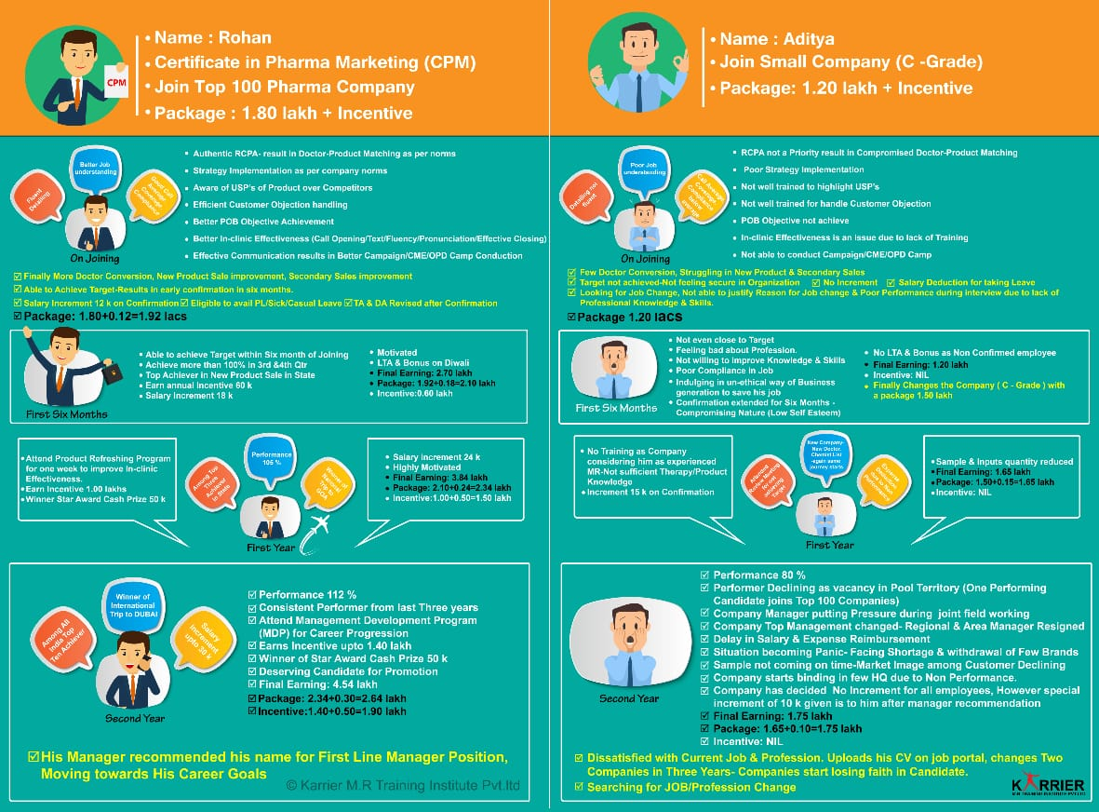

* Title-tag: medical representative training institute near me
* Alt tag: a medical representative case study

Understand Cultural Difference- Top 100 vs Small Companies, download this pdf:

* 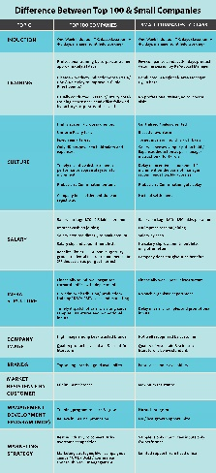   
    
  Title-tag: sun pharma Cipla medical representative job
* Alt tag: Cultural difference- Top 100 vs Small pharma companies

**4. Internship / Colleges / Universities**

**Title tag**

**Graduate >> INTERNSHIP >> High Chances to get hired**

**Meta description**

**CAMPUS to CORPORATE- An internship in pharma sales for graduates. Ideal for Degree college/university placement cell.**

**Industry Tie-ups ⭐⭐⭐⭐⭐**

**Select words to bold in meta description**

**CAMPUS to CORPORATE, degree college/university placement cell**

**Meta keywords**

**Certified soft skill trainer, soft skill trainer, placement drive, campus to corporate, placement drive, campus placement, sales marketing internship, internship in pharmaceutical company, pharma internship, internship in pharma company, graduate internships, internship after b pharmacy, internship after graduation**

To know our journey so far by developing students from tier-II / tier-III cities to kick-start their careers in pharma sales, download this pdf



Student Colleges & Corporate logo need to be changed.

**6. Corporate Training**

H1: **Corporate Sales Training Programs**

**H2: pharmaceutical sales training programs**

**Title tag**

**Corporate Sales Training Programs - Nabigeta Solutionist**

**Meta description**

Anubhav Saxena - Best Sales Trainer & Sales Consultant in India, Sales Trainer and Motivator who transforms businesses.

Best Trainer ⭐⭐⭐⭐⭐

**Select words to bold in meta description**

**Best Sales Trainer & Sales Consultant in India**

**Meta keywords**

**Pharmaceutical sales training program, management development programs, MDP, corporate training, list of training programs for employees development,** corporate soft skills training, pharma sales training, best corporate trainer, best pharma sales trainer,  Freelancer sales trainer consultant





* Title-tag: corporate training program
* Alt tag: Professionals in corporate meeting

## **Key Challenges in Pharma Industry Today**

* • A mediocre strategy can look great provided the execution is par excellence as quoted by Morris Chang “without execution, strategy is useless”. Now the question arises how do we improve the execution, who are the key persons involved & who can make all the difference?
* • Wouldn’t it make life easier for Managers / Leaders / Brand Managers?
* **• Welcome to Nabigeta Solutionist. A guiding light to address your key challenges!!!**

## **What do we do?**

Nabigeta Solutionist imparts professional training to facilitate corporates in strengthening people capability, building brands, augmenting leadership skills, training & nurturing Soft Skills.

## **Why Nabigeta?**

* • At Nabigeta , we understand the key challenges & then customize the programs which helps to get superior outcomes.
* • Trainers at Nabigeta have very rich & proven experience in launching products from strategizing to execution, management development programs & entry-level training.
* • Our strength lies in end-to-end understanding of the business.
* • We believe in a pragmatic approach and delivering solutions which are apt to the organization and provide a return on investment.

## **Target Customer?**

Small-sized Pharma Company having the vision to operate Pan India.

We serve as your extended arm for marketing, HR & training support.

To know how Nabigeta Solutionist makes a difference for small-sized pharma companies, download this pdf:



* Title-tag: sales training program
* Alt tag: Anubhav Saxena- Best Pharma Sales Trainer



* Title-tag: management development program (MDP)
* Alt tag: Nabigeta Solutionist – corporate training program

**7. Gallery**

**karrier.in/gallery**

**8. FAQ**

**karrier.in/faq**